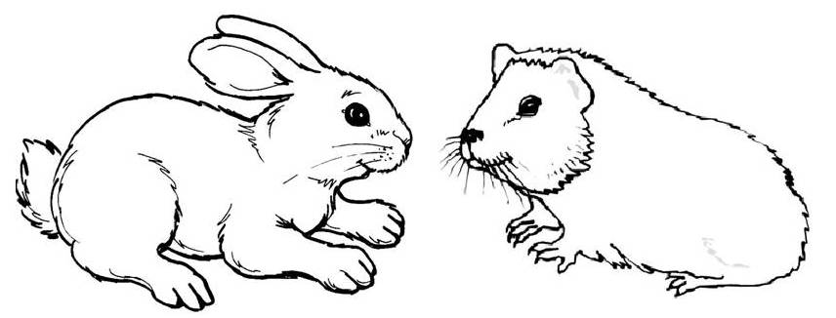
Thank you for choosing Pitlessie Rabbit Retreat and Guinea Pig Care. So that we can provide your pet with the best services possible, please provide us with the following information.

Your details
Name:
Address:
Home telephone number:
Mobile telephone number:
Email address:
Emergency contact number:

Pet Details (Please complete for all pets boarding, continue on a blank page if necessary).
Pet’s name:
Type of pet (rabbit or guinea pig):
Colour and breed:
Pet’s age:
Pet’s gender:
Spayed /neutered: yes/no
Pet’s usual dry food:
Preferred feeding time: am/pm/both
Water bottle or water bowl:
Type of accommodation required: Indoor/Outdoor
Does this pet require medication, have any special care needs or have any history of illness?

Pet’s name:
Type of pet (rabbit or guinea pig):
Colour & Breed:
Pet’s age:
Pet’s gender:
Spayed /neutered: yes/no
Pet’s usual dry food:
Preferred feeding time: am/pm/both
Water bottle or water bowl:
Type of accommodation required: Indoor/Outdoor
Does this pet require medication, have any special care needs or have any history of illness?

Name and address of vet:
Telephone number of vet:
At Pitlessie Rabbit Retreat and Guinea Pig Care, we will take immediate action to get veterinary advice in the event that your pet is ill or injured during their stay with us. By signing this form, you agree that you are happy for your pet to be treated should this be necessary, and that relevant costs will be covered upon settlement of the account.
Date of arrival:
Date of departure:
Drop off and collection times are by prior arrangement and are strictly between the hours of 9.30am and 5pm weekdays & 9.30am-1pm weekends.
Prices:

Single Rabbit - £8 per night or £45 per week
Two or more rabbits sharing accommodation- £5 per rabbit per night or £30 per rabbit per week

Single Guinea Pig - £5 per night or £30 per week
Two or more guinea pigs sharing accommodation - £3.50 per pig per night or £20 per pig per week

Total cost (Calculated per week and per additional nights of stay)
Full weeks (7 nights) = £
Additional nights = £
Total: £
Please add any other information which you feel to be relevant:

Terms and Conditions of Boarding
- For safety, all rabbits must have current Myxomatosis/RHD1 (Nobivac MxyoRHD) & RHD2 (Filavac) vaccinations. Proof of these will be required before any rabbit is accepted for their stay. There are no current vaccination requirements for guinea pigs although it is highly recommended that a recent health check has been undertaken prior to their stay with us.
- All pets must bring with them a plentiful supply of their usual dry food. A fee of £5 will be charged should we have to provide dry food.
- Any pet showing signs of illness or injury may be refused boarding in the interests of safety for other boarders. Pets will not be allowed to mix with other residents and as such no responsibility will be taken for any subsequent illness.
- All male rabbits residing together must be neutered.
- If you fail to collect your pet on the agreed date and we do not have any correspondence from you, we reserve the right to attempt to re-home them. Prior to this, however, we will make every effort to contact you and we will ensure that your pet is safe and cared for. Late collection will incur fees as per the set price list.
- Should your pet require veterinary attention, we will seek this at our local veterinary practice, Wilson and Partners, Cupar. Should you specifically request that your pet be treated at your own usual surgery, transportation costs will apply. Any veterinary bills will be covered by the owner. Please note that we act primarily in the interest of the animal and will not withhold or refuse necessary care at any time.
- Please ensure your pet has been brushed and had their nails clipped if required prior to arrival.
- Drop off and collection times are by prior arrangement and are strictly between the hours of 9.30am and 5pm weekdays & 9.30am-1pm weekends.
- Should you need to cancel your booking we do not charge a fee, but please remember to inform us.

By signing below, you are agreeing to the terms and conditions specified above.
Signed (Owner): (sign on day of arrival)
Please print name:
Signed (Staff):
Date:
Pitlessie Rabbit Retreat and Guinea Pig Care
5 Crossgates
Pitlessie
Cupar
Fife
KY15 7TQ
07831 418860
rabbitretreat@gmail.com

